Ideation Phase
Define the Problem Statements

Date | 19 September 2026
Student ID | 23NU1A4429
Project Name | Automated Network Request Management in ServiceNow
Maximum Marks | 2 Marks

PS-1: The End-User Persona (The Requester)
User Profile
I am an enterprise employee (e.g., Nickolas Khosravi) who requires the provisioning of a new physical network connection or the immediate relocation of existing corporate hardware assets.
Core Objective
My goal is to seamlessly submit hardware profiles, inventory requirements, and physical location coordinates to the IT Infrastructure team to minimize workspace setup downtime.
Technical Friction Points
• Ambiguous Data Ingestion: The legacy service catalog interface is confusing and lacks rigid front-end validation rules, resulting in incomplete ticket submissions.
• Communication Overhead: The current process relies heavily on manual forms and offline email chains to clarify missing physical specifications.
• Static Interface Layout: The form fails to auto-populate my profile identity data or employ conditional client-side UI policies to hide complex relocation parameters unless contextually necessary.
Operational & Emotional Impact
This structural gap creates severe administrative friction, leaving me feeling frustrated, digitally isolated, and operationally delayed when trying to establish my workspace connectivity.

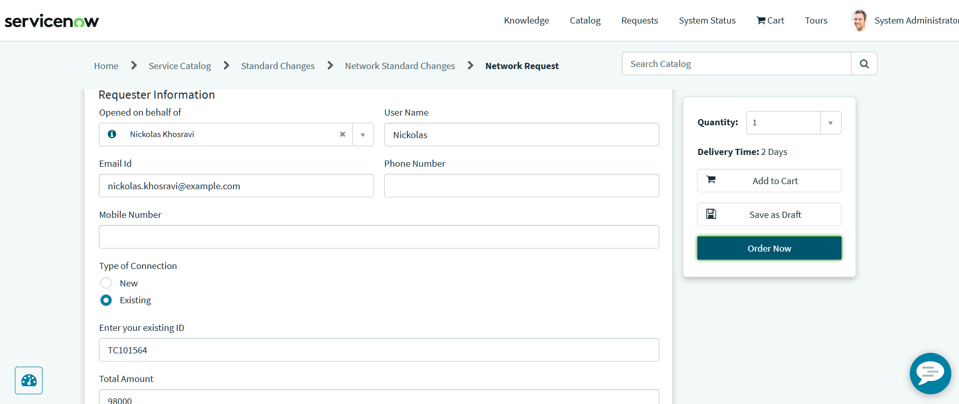

PS-2: The Backend Administrator Persona (The Fulfiller)
User Profile
I am an IT Network Infrastructure Administrator responsible for validating hardware allocations, coordinating technical deployments, and managing regional resource sign-offs. Core Objective
My goal is to maintain a zero-error, persistent configuration management database (CMDB) ledger tracking all network infrastructure assets across the enterprise ecosystem.
Technical Friction Points
• Metadata Deficiency: Inbound provisioning forms frequently arrive missing critical parameters, forcing me to manually verify user profiles and clear up data inconsistencies.
• Manual Bottlenecks: I must manually pursue managers for sign-offs and transcribe hardware configurations line-by-line into disconnected spreadsheet tracking files.
• Lack of Orchestration: The current architecture completely lacks strict, entry-gate input validation and an automated server-side engine (such as Flow Designer) to handle multi-stage approval routing and direct database commits.
Operational & Emotional Impact This system deficiency introduces significant technical debt, leaving me feeling overwhelmed by repetitive administrative workflows and anxious about data corruption, clerical errors, or broken asset dependencies.
